MONDAY | TUESDAY | WEDNESDAY | THURSDAY | FRIDAY
1  Cereal  100% Fruit Juice  Fruit  Milk | 2  Cinnamon Roll  100% Fruit Juice  Fruit  Milk | 3  Bagel w/ Cream Cheese  100% Fruit Juice  Fruit  Milk | 4  Cinnamon Crumb Loaf  100% Fruit Juice  Fruit  Milk | 5  Apple Frudel  100% Fruit Juice  Fruit  Milk
8  Cereal  100% Fruit Juice  Fruit  Milk | 9  Bakery Bread  100% Fruit Juice  Fruit  Milk | 10  Bagel w/ Cream Cheese  100% Fruit Juice  Fruit  Milk | 11  Benefit Bar  100% Fruit Juice  Fruit  Milk | 12  Cinni Mini’s  100% Fruit Juice  Fruit  Milk
15 | 16  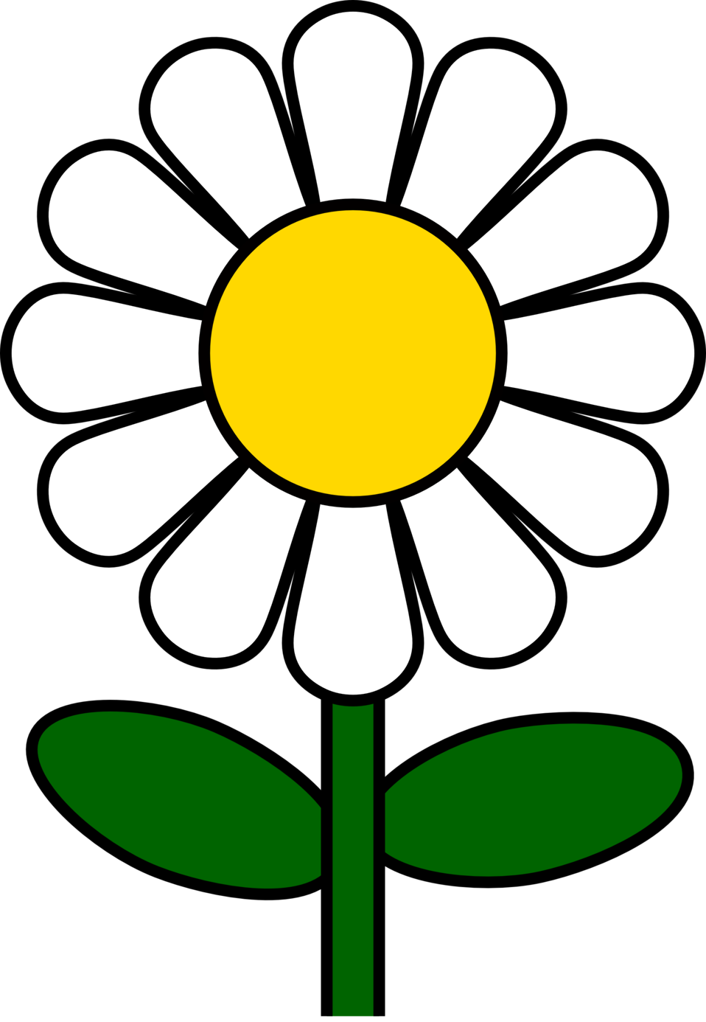 | 17  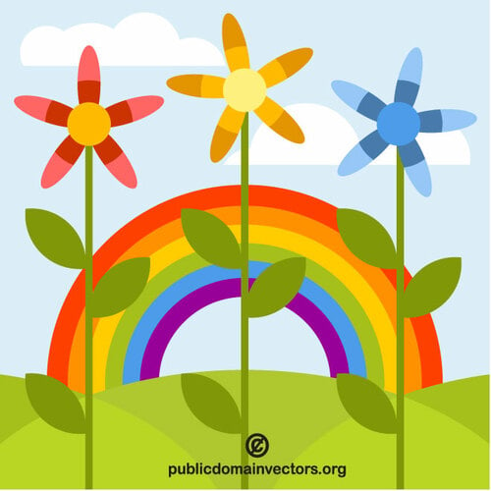 | 18  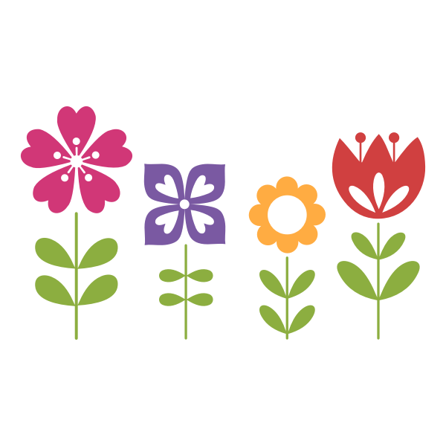 | 19
22  Cereal  100% Fruit Juice  Fruit  Milk | 23  Breakfast Bar  100% Fruit Juice  Fruit  Milk | 24  Yogurt w/ Granola  100% Fruit Juice  Fruit  Milk | 25  Muffin  100% Fruit Juice  Fruit  Milk | 26  Bagel w/ Cream Cheese  100% Fruit Juice  Fruit  Milk
29  Cereal  100% Fruit Juice  Fruit  Milk | 30  Bagel w/ Cream Cheese  100% Fruit Juice  Fruit  Milk
Breakfast: Free Milk: $.50

